EEM Correction and Data Export Instructions

**Section 1:** Preparation of Data for Analysis in Matlab

1) **Download** the EEM Folder Template from the Aqualog Channel within the MCRL MSL-5 Laboratory Coordination Teams Channel. This folder contains 6 subfolders named ‘1. Absorbance’, ‘2. Blanks’, ‘3. Raw EEMs’, ‘4. Corrected_EEMs’, ‘5. Figures’, and ‘6. Final_Data’. A file called ‘SampleLog.xlsx’ is also present.

-Again, **download** template to your local drive. **DO NOT** work directly in this folder template on the TEAMs channel

-Rename the Primary Template Folder to whatever you like

-Do **NOT** change the names of the subfolders or the SampleLog (or tab within)

-Example files are included should one want to practice with Matlab. Delete these before adding your data and sending them for off corrections.

2) Move all Absorbance, Blanks, Raw EEMs to their respective folders.

3) Open the file ‘SampleLog.xls’ and fill out columns for each sample



-A: Index: Simply the numeric order of entry (e.g. 1, 2, 3, 4, etc…)

-B: Analysis Date: Data samples were ran on instrument (not collected in the field)

-C: Sample Description: A brief description of the sample collected – 60-character max.

*Note: This description will be displayed on the top of final EEM figures

-D: Sample ID: Sample Identifier

*Note: This Sample ID will be used as the base naming for EEM figures

*\*Note: Biological replicates should be treated as a normal sample and have independent Sample IDs marked as A, B, C, etc…*

-E: Analytical Replicates: Numeric (1, 2, 3,etc…)

\**Analytical Replicates must have identical Sample IDs.*

-F: EEM File Name: Must include **EXACT** filename of EEM file.

*\*Don’t forget file extension (e.g. .dat, .xls, etc…)*

-G: EEM Blank: Must include **EXACT**  file name of EEM Blank file

\**Don’t forget file extension (e.g. .dat, .xls, etc…)*

-H: Absorbance File Name: Must include **EXACT** filename of Absorbance file.

*\*Don’t forget file extension (e.g. .dat, .xls, etc…)*

-I: Absorbance Pathlength: For Aqualog, this will always be 1.

-J: Integration Time: Integration time of sample (e.g. 0.1, 1, 2, 4)

-K: Raman 1s Area: Put the Raman 1s area that was recorded at the beginning of the day. This will be the same for all samples ran on the same day, but slightly different across samples ran over multiple days. At MCRL, this value is normally around 2950-3000.

-L: Dilution Factor: Include dilution factor here as decimal format (e.g. a 2-fold dilution with 1 part sample and 1 part water will have a dilution factor of 0.5). ***Otherwise, put 1.***

K: DOC concentration in mg/L of the original in situ sample (not the diluted sample).

6) If you have access to Matlab, continue forward with instructions. If you do not have access to Matlab, generate a zip file and forward to someone who can do the processing for you.

**Section 2:** Matlab Setup (This step is only required for the first use of this code on any given computer. If you have already done this section, proceed to Section 3)

1) Download the latest version of the drEEM toolbox (<http://dreem.openfluor.org/>). Unzip the folder and place it somewhere accessible on your machine (e.g. the desktop).

2) Download the ‘Supporting Matlab Files for EEM Corrections’ from the Aqualog Channel of the MCRL MSL-5 Laboratory Coordination Teams Channel.

2) Cut and paste the ‘Supporting Matlab Files’ folder over into your drEEM folder. It is fine for this folder to remain a subfolder of the main drEEM folder

-This folder contains the following files:

A) manualplots, B) SpectralIndicesExport, C) EEM_Processing_Code

3) Open Matlab. Click on the ‘Set Path’ icon, then click the ‘Add with Subfolders…’ button. Select your drEEM folder. This will allow all of the subfolders and files within your drEEM folder to be accessed by Matlab

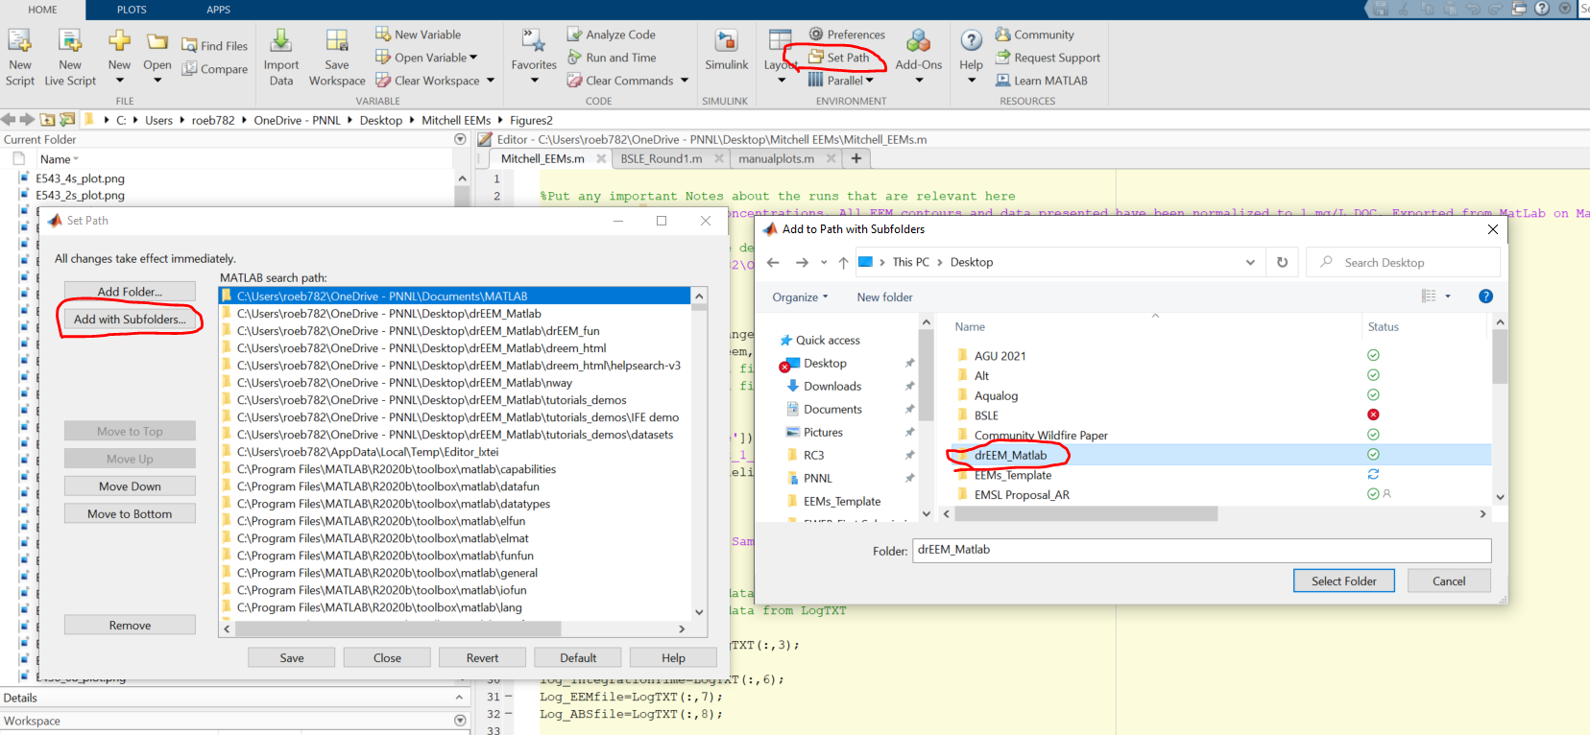

**Section 3:** Running Matlab script to export EEM data

1) Open in Matlab the file ‘EEM_Processing_Code’

Note: This code is good for samples ran in manual mode on the Aqualog. Samples ran using the Sample Queue may require edits to ensure Matlab reads the files correctly

2) Make edits to the Code in Section 1 as necessary. Note that any changes made will autosave

Line 5: Specify if using a mac by indicating ‘true’ or ‘false’

Line 8: Add any special notes about the samples or processing. These notes will be added to the ReadMe in the final data file.

*Note: Code corrects for dilutions and normalizes all data to

1 mg/L DOC. This information is generally specified here plus anything extra that might be important

Lines 11-17: Specify parameters for viewing or saving EEM figures

*Default settings are to autoscale (manualscale=false) the intensity scale of EEM contours, autosave EEMs (autosave=true), and save with a figure title (figuretitle=true)

*To set the intensity scale of all EEMs to be consistent, set the clim_max on line 10 to whatever value you choose and change line 11 to manualscale=true

*Note when autosave=true, nrows and ncols must each be set to 1. If you prefer not to save EEMs and simply want to view them, set autosave=false. You may then also change the nrows and ncols to view EEM contours in a matrix.

Line 20: Specify your study code: will be used for naming final output data

Line 25: Specify with true or false whether DOC concentrations are available in the sample log. When DOC is available, data will be exported as both Raw and DOC normalized. When DOC is not available, data will be exported as Raw data only. SUVA is also not available in the final sample file. It is **highly recommended** to only run the code when DOC is available to keep data outputs consistent. However, the code was made amenable here in the event one is in a bind and needs data quickly but may not have DOC.

Line 26: If DOC is available, specify if you would prefer figure outputs to be DOC normalized by specifying ‘true’ or ‘false’. A response of ‘false’ provides figures as the raw data (RSU).

Line 29: Specify the path to the folder that contains all of your data and the SampleLog

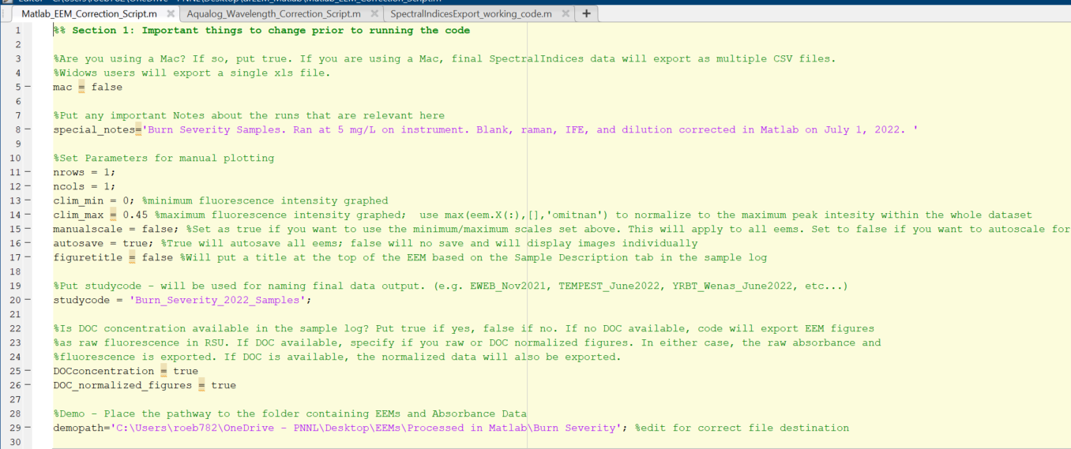

3) Press the run button:

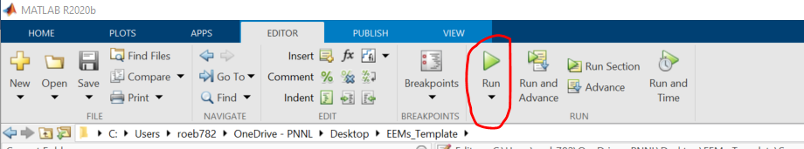

4) Matlab will now import the Absorbance, EEM blanks, and raw EEM files. The code will blank subtract all EEMs, inner filter correct, raman normalize, correct for dilutions, and if DOC is available, normalize data to 1 mg/L.

*All corrected EEMs will be reexported into the ‘Corrected_EEMs’. Note these corrected files only represent blank subtracted, inner filter corrected, and raman normalized EEMs.

*All EEM contours will be saved in the ‘Figures’ folder.

*A file called ‘#_SpectralIndices.xlsx’ will be exported to the Final_Data folder.

* # is whatever you put as the study code on line 20

5) Note, the code should run all the way through and will provide you with a message letting you know you are finished. If the code stops at any point, there is an error somewhere. Most common errors are:

1) Actual file names are not identical to what is specified in the SampleLog

2) Extra files are included folders that aren’t specified in the SampleLog